

NAME – VAIBHAV KHARE

EMAIL ID – [VAIBHAV.KHARE96@GMAIL.COM](mailto:VAIBHAV.KHARE96@GMAIL.COM)

QUESTION 1 – Create a blank file named “myfile”

Ans – Creating and verifying myfile

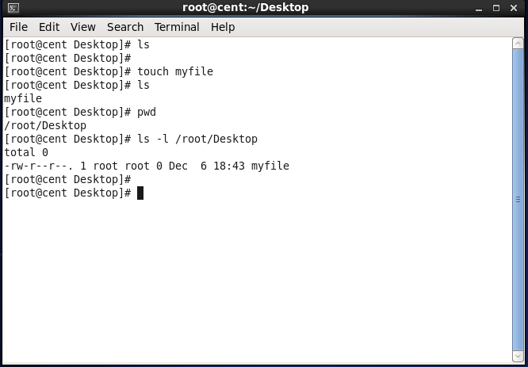

Question 2 – Open “myfile” in vi editor

Ans – Opening myfile using vi editor

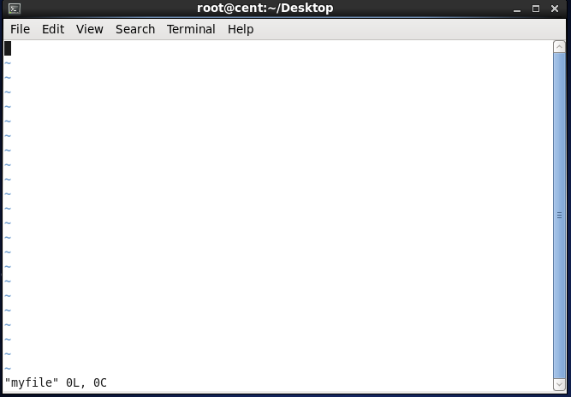

Question 3 – Write your name, address, email id, . . phone number and blood group in 5 different lines

Ans - Writing the details saving it by using wq! . . . Command and then opening it by using cat command

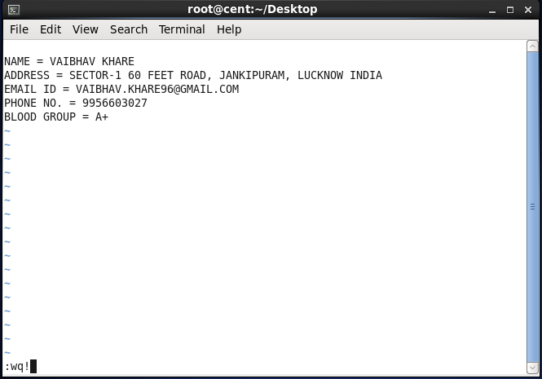

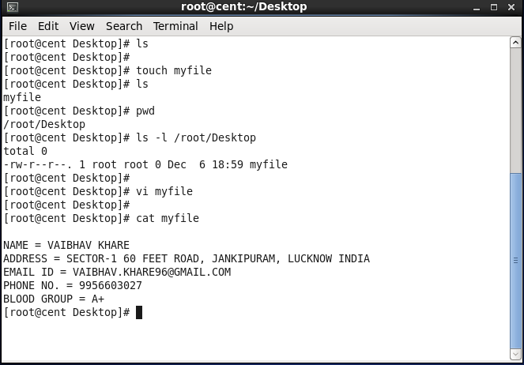

Question 4 – Build one single expression to . . see the line with your name and blood group in . . . myfile

Ans – Creating one single expression to find the . . name and blood group line

